**TEAM5OARS**

**TEAM5OARS Database Implementation Screenshots**

***Version 1.0***

**Approvals Signature Block**

|  |  |  |  |
| --- | --- | --- | --- |
|  | **Name** | **Signature** | **Date** |
| Team Leader |  |  |  |
| DBA |  |  |  |
| DBA |  |  |  |
| SQA |  |  |  |

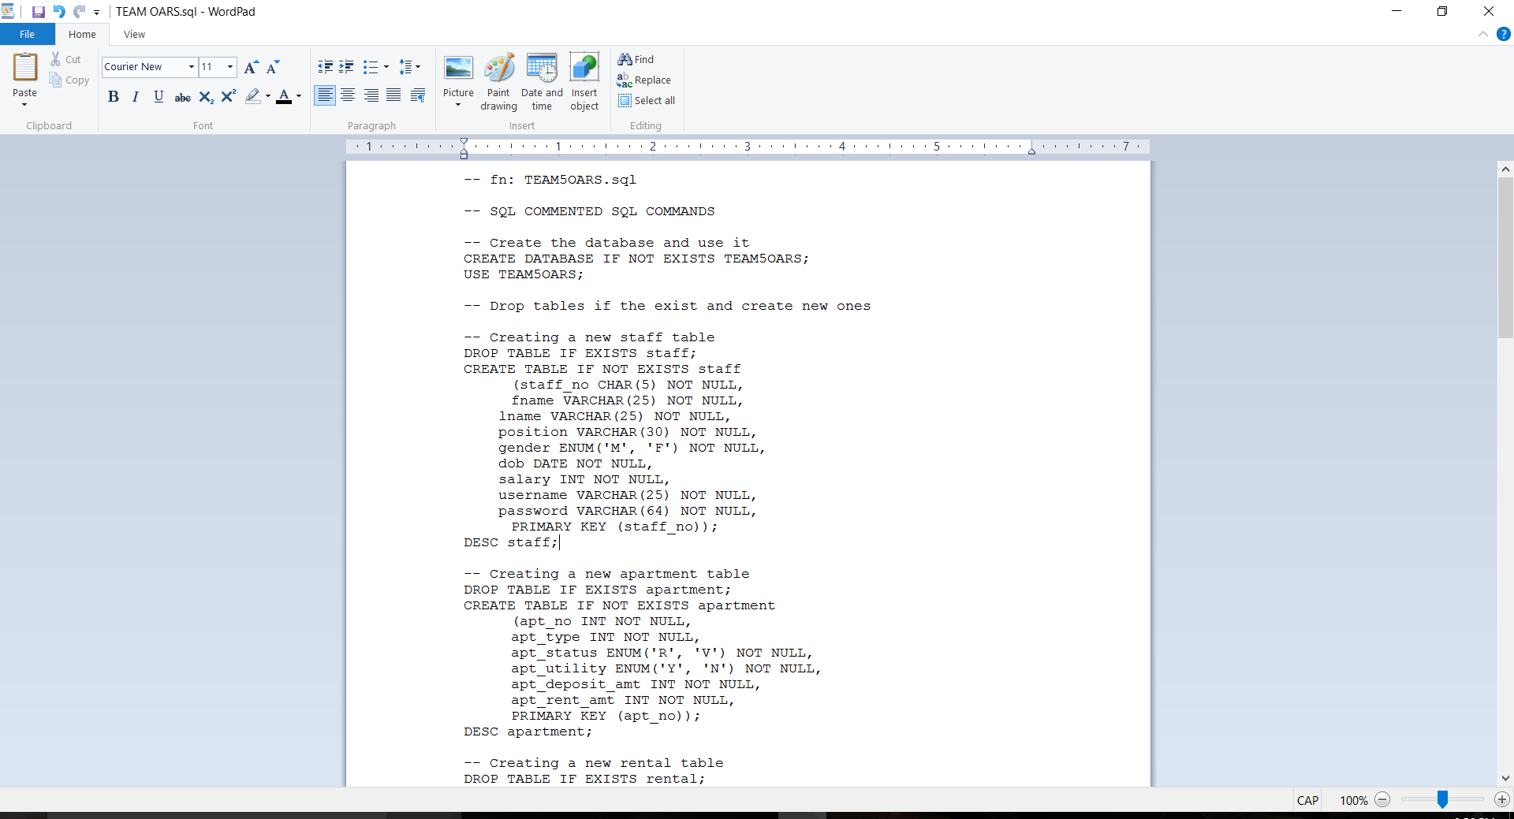

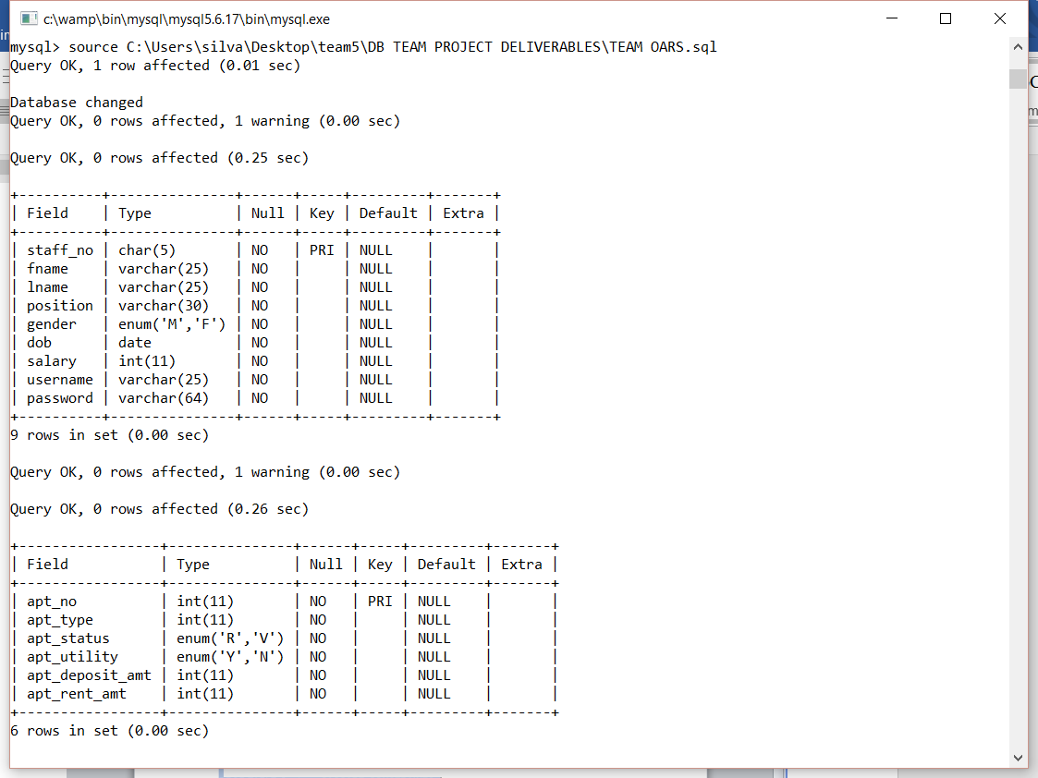

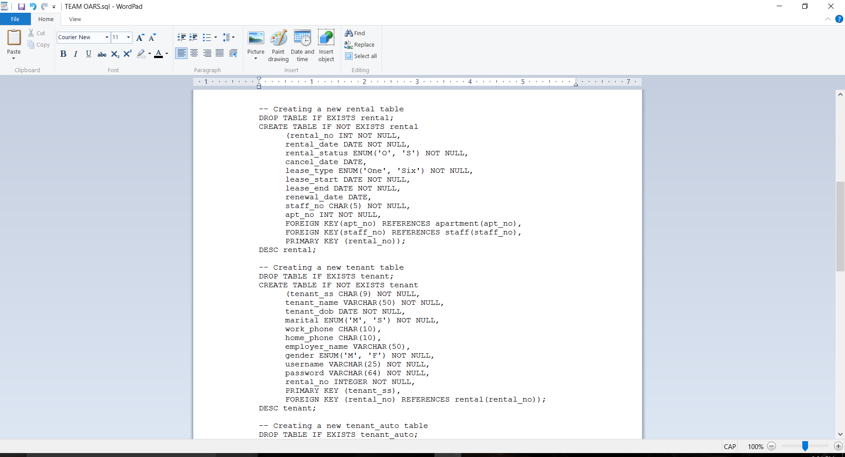

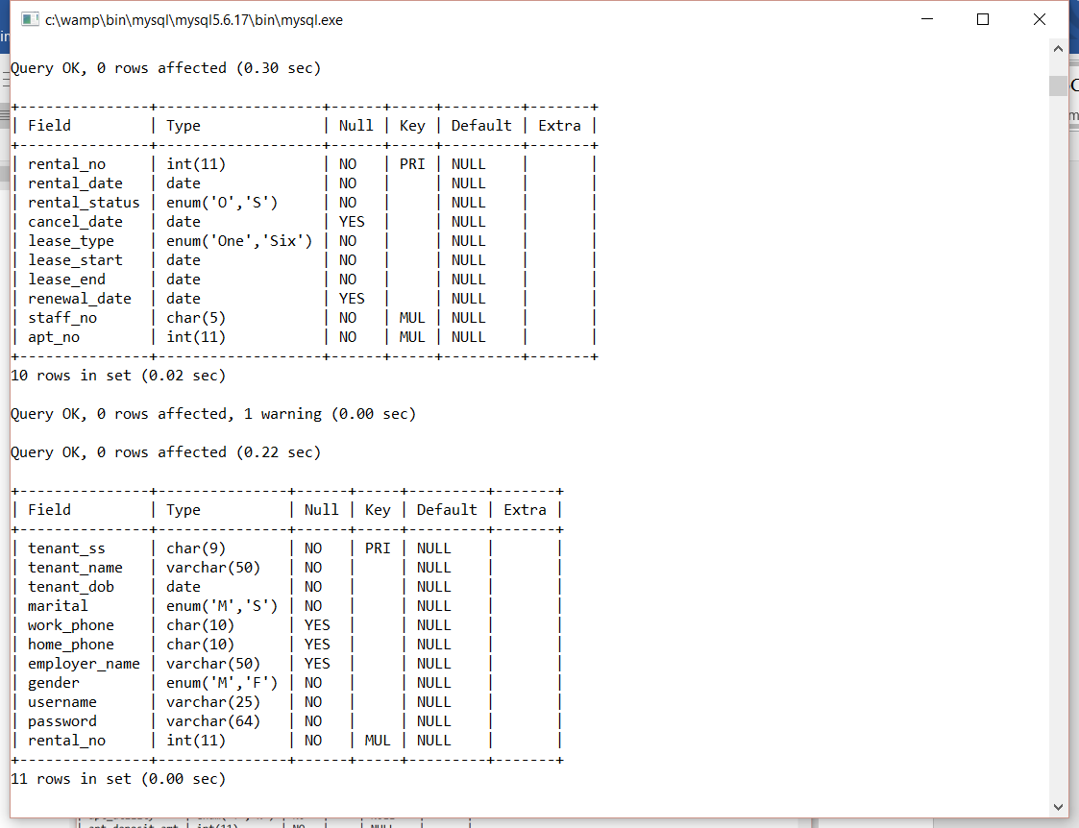

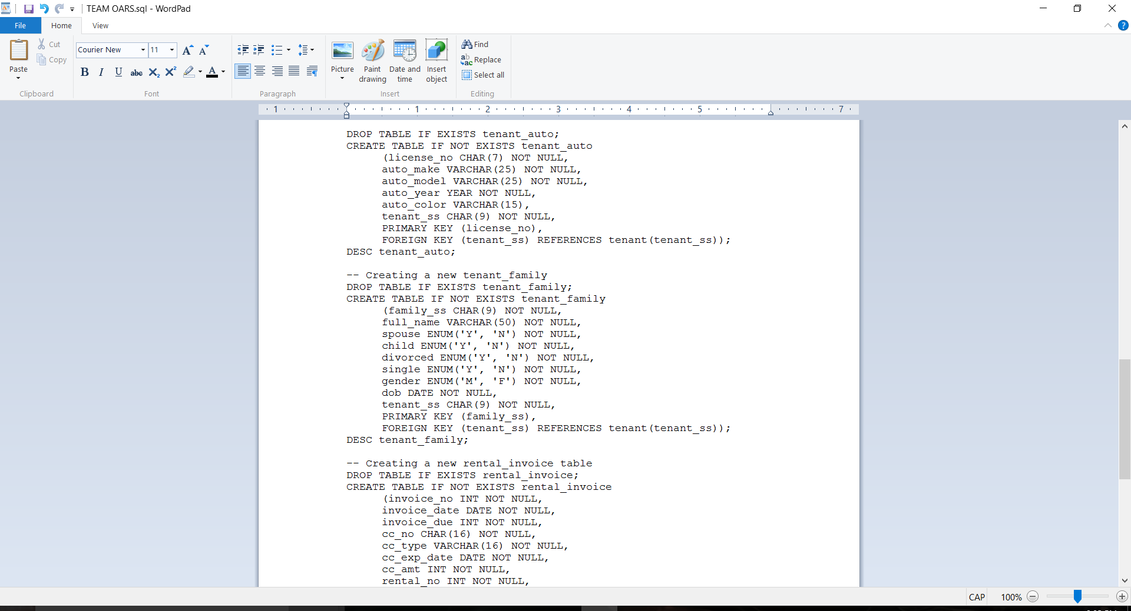

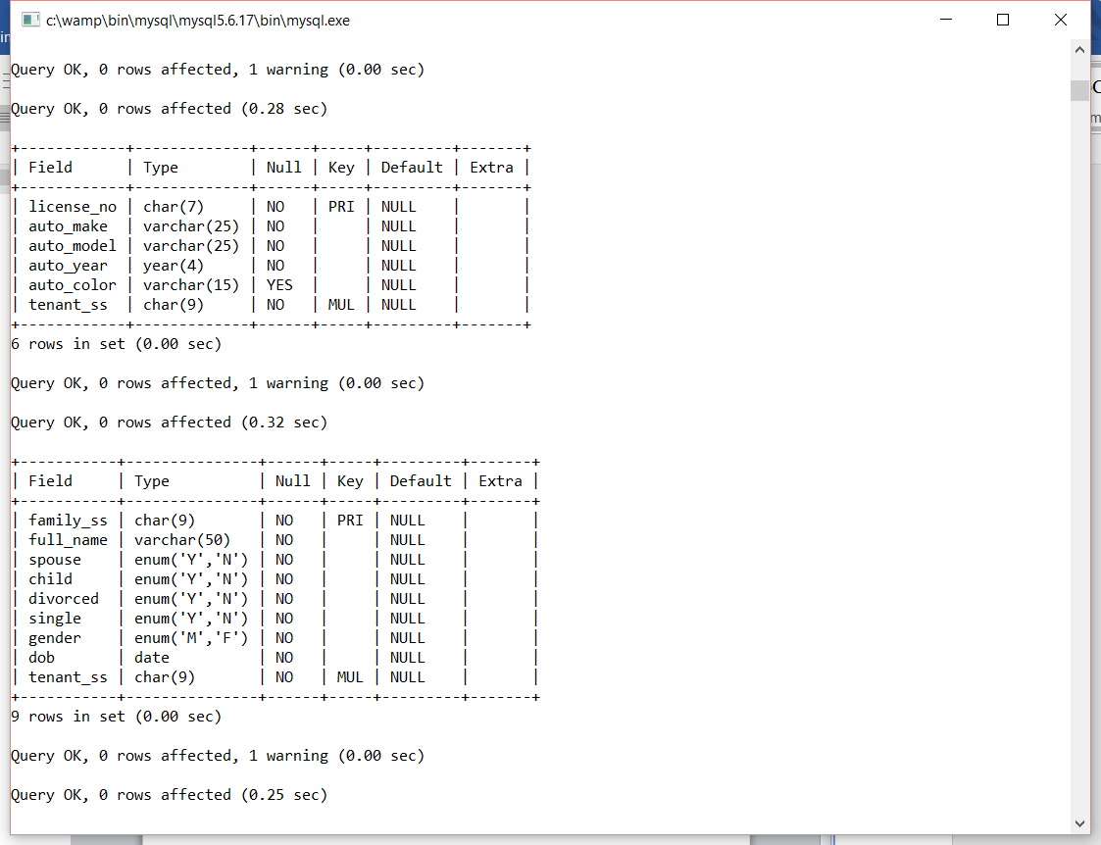

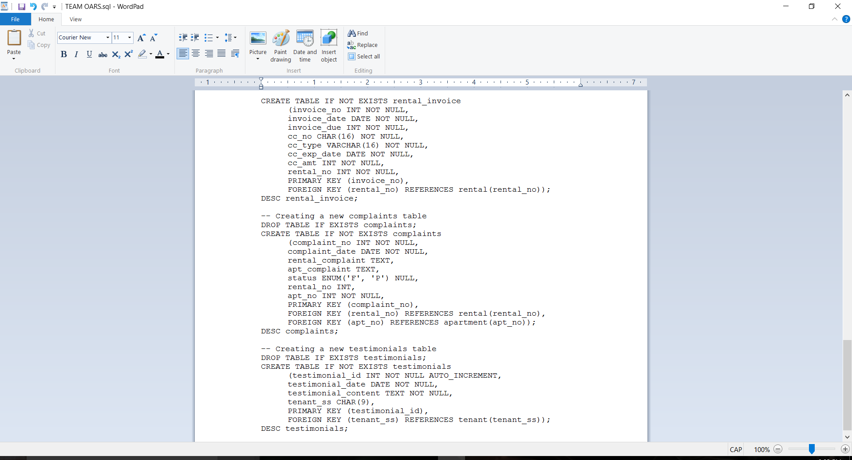

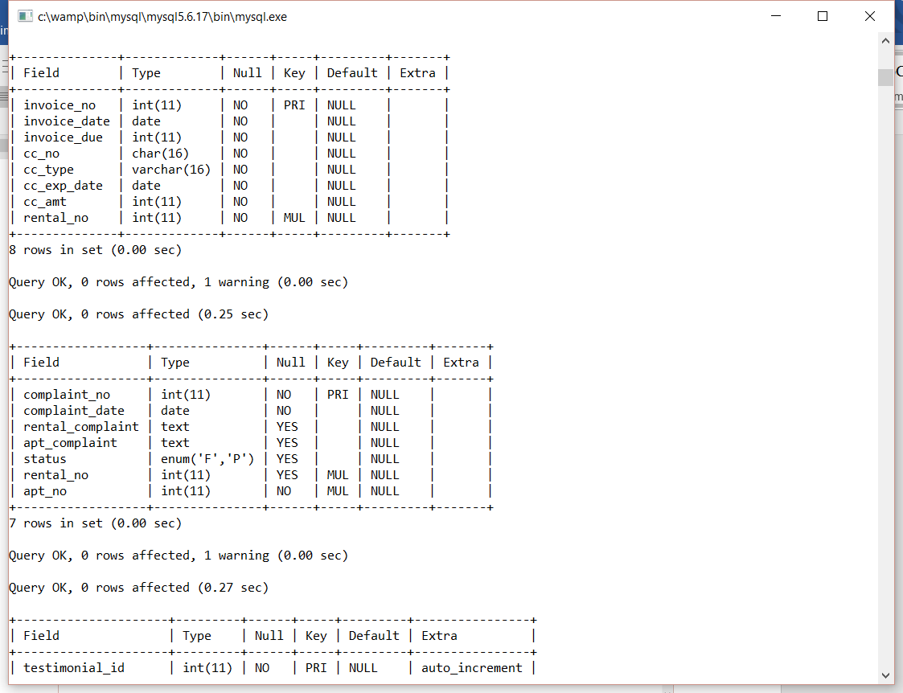

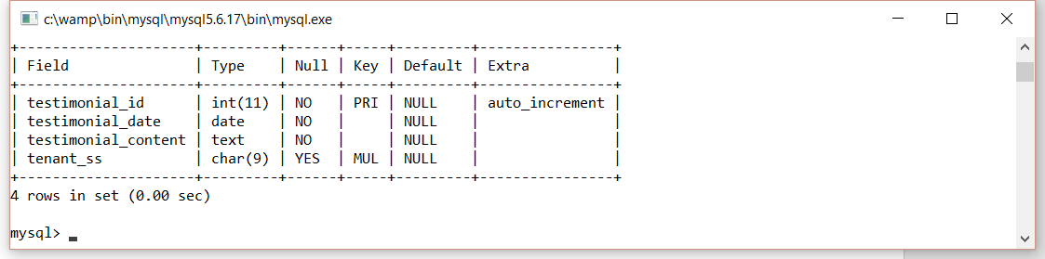

**Document Control**

Change History

**(PLEASE REMOVE THIS BEFORE COMMITTING TO SVN!**

**NOTE: Team Leaders should place the TMs and SQAs Names, Due Dates, Description BEFORE this document is released in SVN to DBAs & SQA!)**

**Table 1: TLs entries (assigned work and due dates) before releasing to the team**

|  |  |  |  |
| --- | --- | --- | --- |
| Revision | Name | Due Date | Description |
| 1.A | Nixon Mathew – DBA | 04/09/2016 | Complete screenshots |
| 1.B | Anthony Cortes - DBA | 04/09/2016 | Complete screenshots |
| 1.C | Luis Silva - SQA | 04/10/2016 | Review Document |

**Table 2: Entries when work completed (SVN Commit Comment matches Description)**

|  |  |  |  |
| --- | --- | --- | --- |
| Revision | Name | **Completed Date** | Description |
| 1.A | Nixon Mathew – DBA | 04/09/2016 | I completed screenshots |
| 1.B | Anthony Cortes - DBA | 04/09/2016 | I completed screenshots |
| 1.C | Luis Silva - SQA | 04/10/2016 | I reviewed the document |

**(PLEASE REMOVE THIS BEFORE COMMITTING TO SVN!**

**NOTE: At the time of BLUE TEAMS DELIVERABLES, the Team Leaders should change the version on the COVER PAGE to 2.0 BEFORE COMMITTING back to SVN!!! Thus the last entry in CHANGE HISTORY should be the TLs)**

**Table 3: TL entry for RED DELIVERABLES (SVN Commit Comment matches Description)**

|  |  |  |  |
| --- | --- | --- | --- |
| Revision | Name | Due Date | Description |
| 2.0 | TL Name | XX/XX/XXXX | I changed Version to 2.0 |

Document Storage

This file is stored in SVN at https://svn.cs.uh.edu/svn/cs4351/team**?**/DB TEAM PROJECT DELIVERABLES/ **TEAM?OARS.doc**.

**(PLEASE REMOVE THIS BEFORE COMMITTING TO SVN!**

**NOTE: Team Leaders should change ONLY the ? with their team number!!!**

**DO NOT CHANGE the name of the document!!!! It will stay TEAM?OARS.doc!!!)**